AWS S3 and IAM Access Control
Lab Report

Objective
To examine how AWS Identity and Access Management (IAM) permissions control access to Amazon S3 and Amazon EC2 operations, observe authorization failures, and verify how appropriate permissions allow specific operations.

Overview
The lab documents failed and successful S3 uploads, examination of IAM roles, testing of object ACL permissions, creation of a new S3 bucket, and access-denied messages in the EC2 console. The results illustrate that permissions are evaluated per action and resource; permission to perform one operation does not automatically grant permission for other operations.

Learning objectives
- Attempt to upload different file types to Amazon S3.
- Observe and interpret Access Denied errors.
- Inspect IAM roles associated with the AWS account.
- Relate IAM permissions to individual S3 operations.
- Verify a successful upload after the relevant access configuration is available.
- Test object-level permissions, including access to an object's ACL.
- Create an S3 bucket and test object upload permissions separately.
- Observe permission restrictions in the Amazon EC2 console.

1. Initial S3 upload attempts
The first upload attempts failed with Access Denied errors. The console results indicate an authorization problem rather than a restriction based on the uploaded file's type.

1.1 Upload of Lab 2.ipynb
The upload attempt for Lab 2.ipynb (approximately 467 KB) reported zero successful files and one failed file. The error is consistent with the active IAM identity lacking permission to upload objects to the destination bucket, such as s3:PutObject.
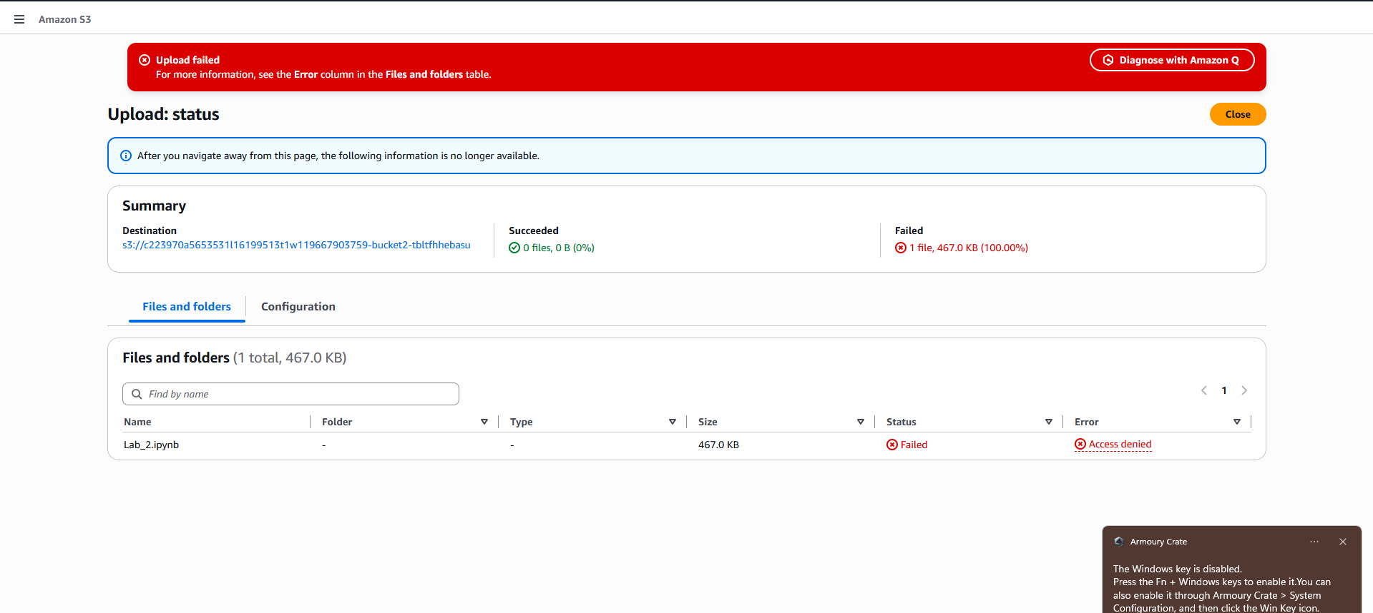
Figure 1. Initial S3 upload failure for Lab 2.ipynb.

1.2 Upload of Lab 1 and 2.docx.pdf
A second attempt to upload Lab 1 and 2.docx.pdf (approximately 408.1 KB) also failed with Access Denied. Because both a notebook and a PDF were rejected, the observations point to an authorization issue rather than a file-format issue.
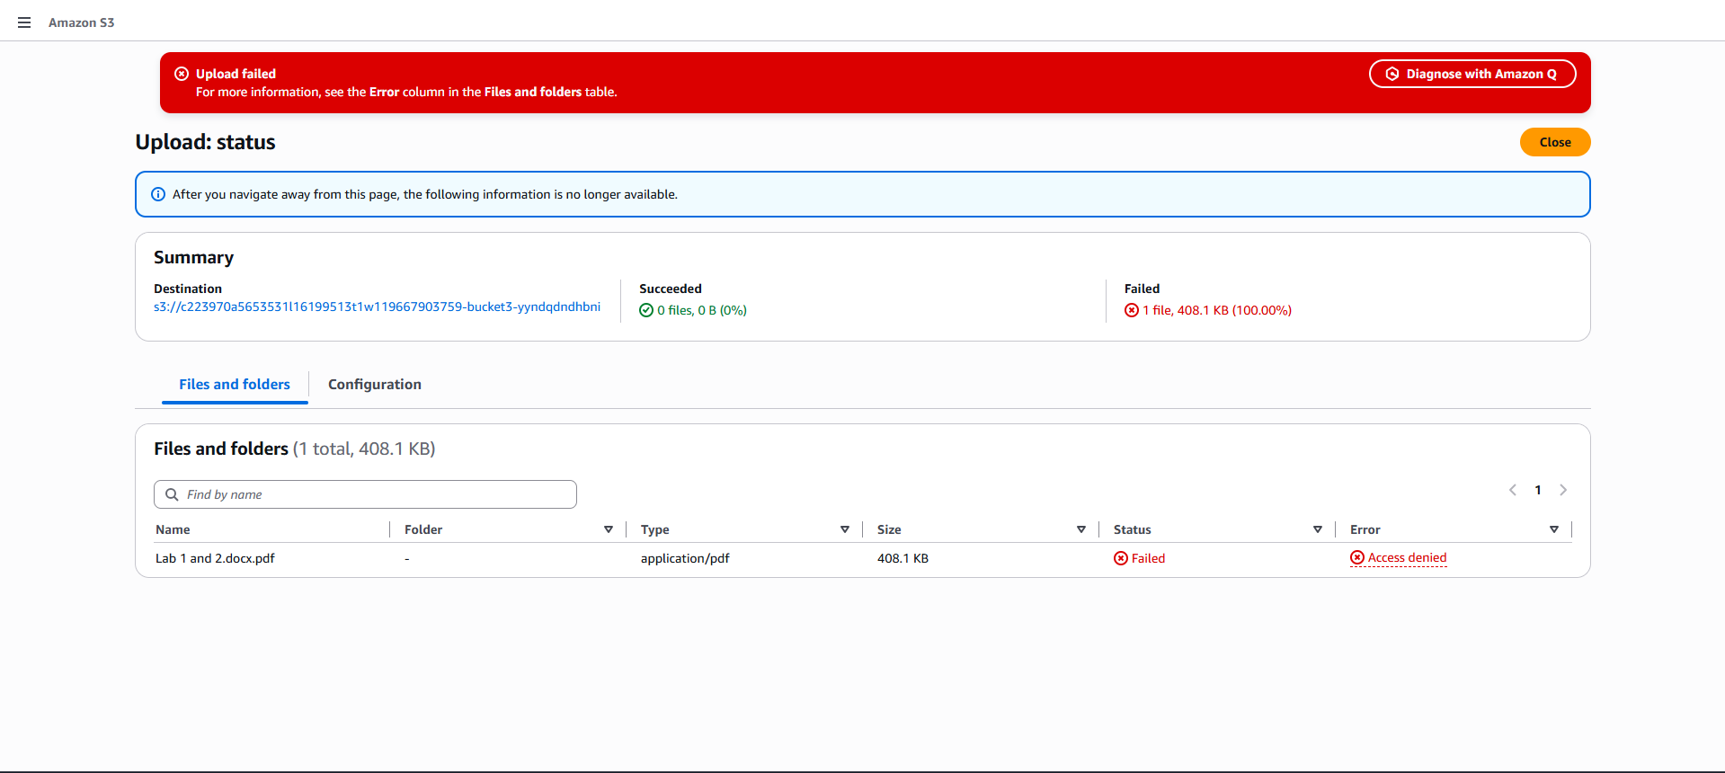
Figure 2. S3 upload failure for a PDF file.

1.3 Upload of an image file
An image upload also initially failed with Access Denied before the relevant access configuration was used. This further illustrates that S3 authorization is independent of file type.
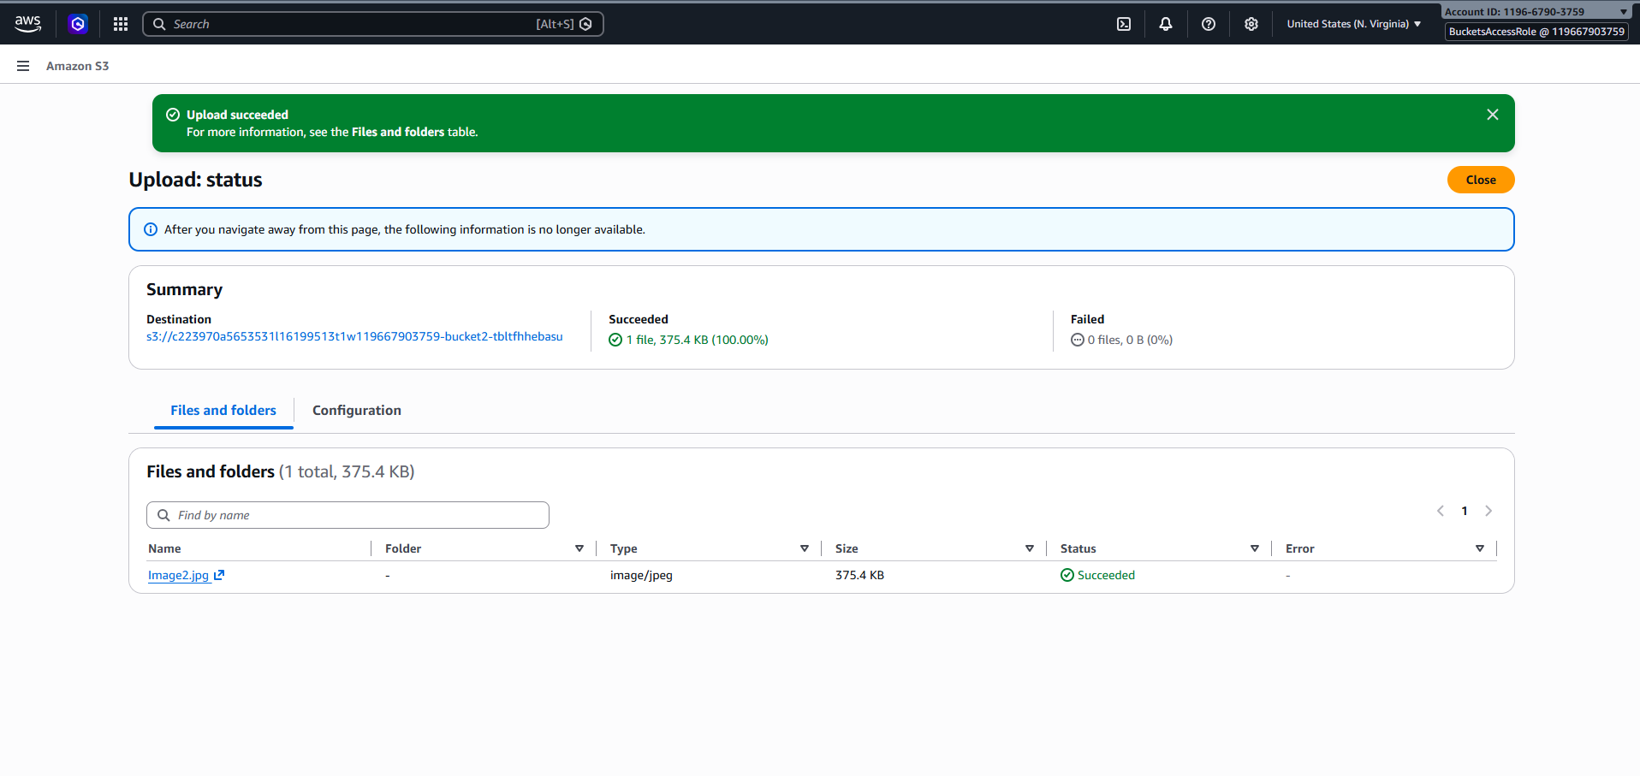
Figure 3. Upload result for the image file.

2. Examination of IAM roles
The IAM Roles page was inspected. The source report identifies roles including BucketsAccessRole, OtherBucketAccessRole, and LambdaS3Role. The presence of roles with S3-related purposes prompted further examination of the permissions available to the acting identity.
IAM permissions can be provided through policies attached to users, groups, or roles. A role with suitable S3 permissions can allow an operation that the current identity cannot perform.
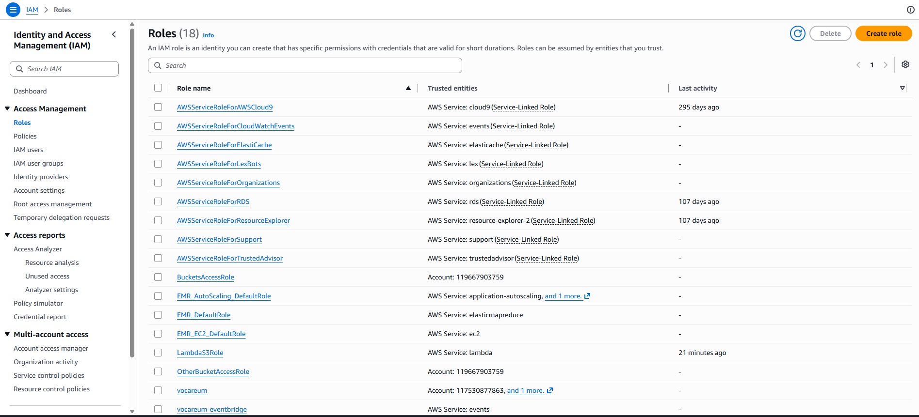
Figure 4. IAM roles available in the account.

3. Successful S3 upload
After the relevant access configuration was used, Image2.jpg (approximately 375.4 KB, image/jpeg) uploaded successfully. The console showed one successful file and zero failed files. This verifies that the acting identity had permission equivalent to or including s3:PutObject for the destination object.
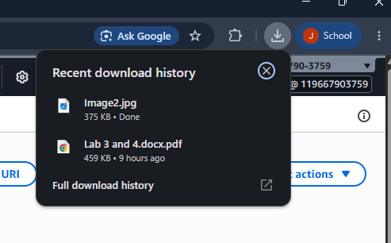
Figure 5. Successful upload of Image2.jpg.

4. Object permission and ACL testing
After uploading Image2.jpg, the object's Permissions tab was opened. The console displayed an error stating that the identity did not have permission to get the object ACL. The source report identifies s3:GetObjectAcl as the permission required for that operation.
This shows that permission to upload an object does not automatically grant permission to inspect its ACL or manage all of its security settings.
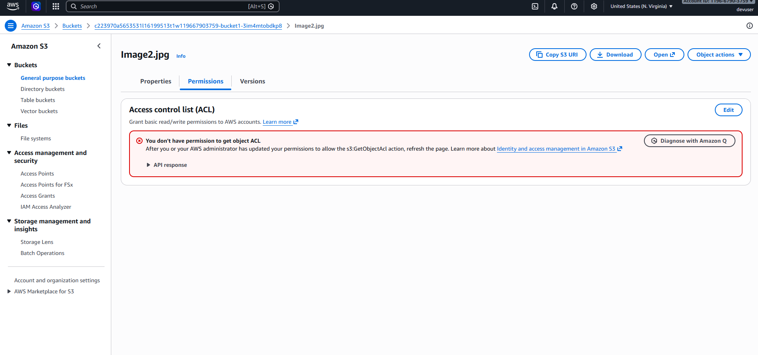
Figure 6. Object Permissions tab and ACL access-denied message.

5. Creation of a new S3 bucket
A new bucket named jis2026 was created successfully. The console confirmed the creation, and the bucket initially contained no objects. The ability to create a bucket is separate from the permission to upload objects into it.
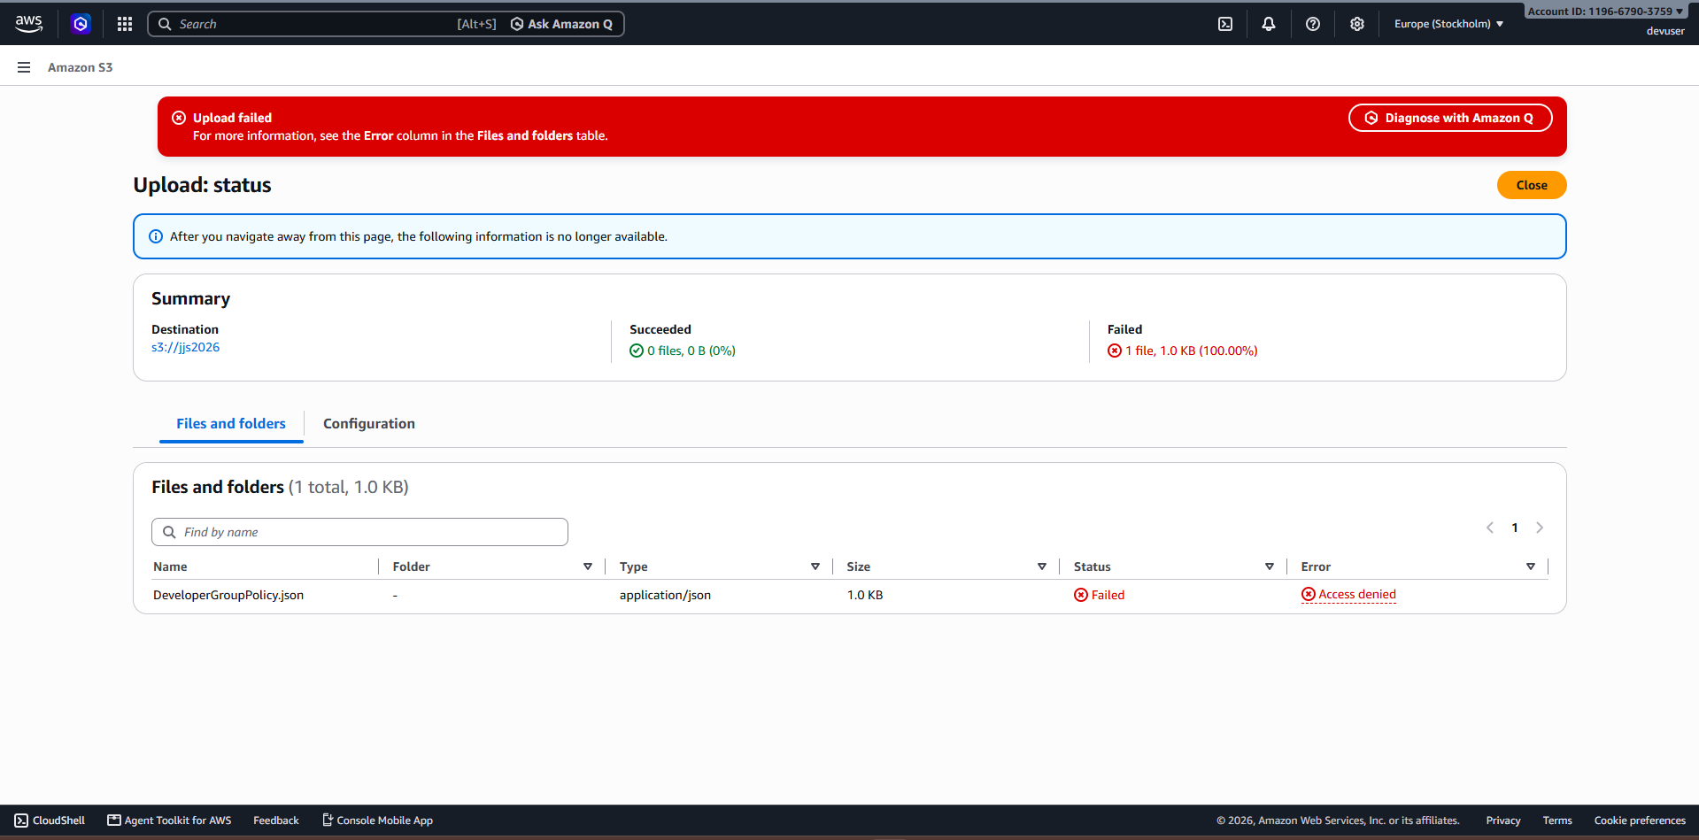
Figure 7. New S3 bucket creation and initial state.

6. Upload attempt to the new bucket
An attempt to upload DeveloperGroupPolicy.json to jis2026 failed with Access Denied. This demonstrates that creating a bucket does not imply unrestricted object-upload permissions. Authorization can be affected by identity policies, bucket policies, explicit denies, organization policies, permission boundaries, session policies, or lab-environment restrictions.
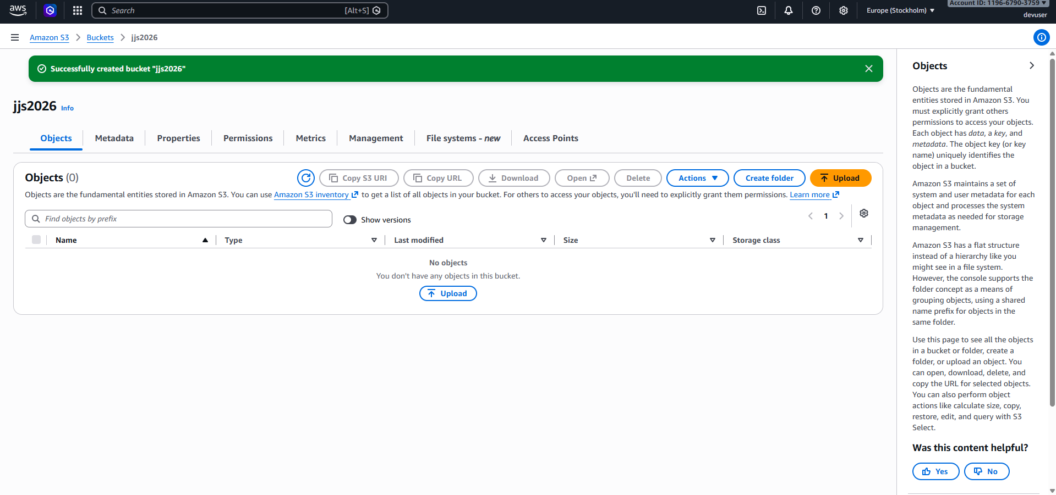
Figure 8. Failed upload of DeveloperGroupPolicy.json.

7. Amazon EC2 permission issues
The EC2 dashboard displayed access-denied messages for several resource categories, including instances, Auto Scaling groups, capacity reservations, dedicated hosts, Elastic IPs, key pairs, load balancers, security groups, snapshots, volumes, Availability Zones, account attributes, and scheduled events.
The console specifically identified missing permissions such as ec2:DescribeAccountAttributes and ec2:DescribeAvailabilityZones. These observations are consistent with a restricted IAM identity that does not have broad EC2 read permissions.
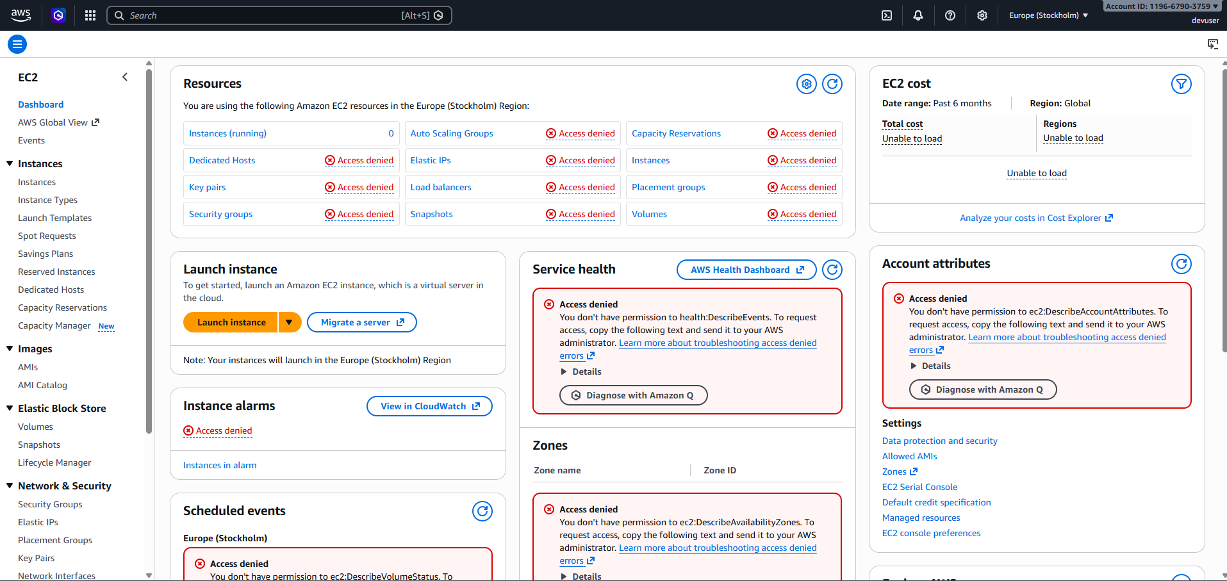
Figure 9. EC2 console showing restricted access to resources.

8. Analysis of access-denied errors
AWS evaluates whether a principal is authorized to perform a particular action on a particular resource. A useful conceptual model is:
Principal → Action → Resource → Policy evaluation
For example, an identity may request s3:PutObject on an object resource such as arn:aws:s3:::bucket-name/object-name. If no applicable policy allows the operation, it is denied by default. An explicit Deny can also override an Allow.

9. Permission reference
The source report identifies the following permissions as relevant to the tested operations. Exact resource ARNs and surrounding policies must be checked in the target environment.
Operation | Permission noted in the report
Upload an object | s3:PutObject
Retrieve an object | s3:GetObject
View an object's ACL | s3:GetObjectAcl
List objects in a bucket | s3:ListBucket
Create a bucket | s3:CreateBucket
View EC2 account attributes | ec2:DescribeAccountAttributes
View Availability Zones | ec2:DescribeAvailabilityZones

10. Key findings
- Initial uploads of multiple file types failed with Access Denied.
- The failures were consistent with authorization restrictions rather than file type.
- IAM roles were inspected to identify roles potentially associated with S3 access.
- Image2.jpg uploaded successfully after the relevant access configuration was used.
- Successful upload did not grant permission to retrieve the object's ACL; the source report identifies s3:GetObjectAcl as the required permission.
- The jis2026 bucket was created successfully, but uploading DeveloperGroupPolicy.json still failed.
- The EC2 console showed missing Describe permissions for several resource views.
- The experiment demonstrated that AWS permissions are granular and evaluated separately for different actions and resources.

11. Recommendations
- Review the IAM policies attached to BucketsAccessRole and other relevant roles.
- Verify that S3 policies specify the intended bucket and object ARNs.
- Grant s3:PutObject only where upload access is required.
- Grant s3:GetObjectAcl only when ACL inspection is necessary.
- Use the IAM Policy Simulator to test permissions before performing operations.
- Review bucket policies for explicit Deny statements.
- Avoid broad permissions such as s3:* or ec2:* unless there is a justified need.
- Follow least privilege and distinguish bucket-level permissions from object-level permissions.
- Investigate lab-environment restrictions if an operation remains denied despite apparently correct permissions.

12. Conclusion
The lab provided practical observations of how IAM permissions govern Amazon S3 and Amazon EC2 operations. The failed upload attempts, successful upload after access configuration, denied ACL retrieval, successful bucket creation followed by a failed object upload, and restricted EC2 console views show that authorization is determined for specific actions and resources rather than granted broadly at the service level.
The results reinforce the importance of reviewing IAM roles and policies, specifying the correct resource scope, and following the principle of least privilege.

Security note
Before sharing this report publicly, review screenshots for account identifiers, bucket names, object URLs, or other environment-specific information you do not want to disclose. Do not publish credentials or tokens. Treat permission changes as controlled lab actions and avoid granting broad access merely to suppress an error.

Appendix A — Original screenshots
The screenshots below are retained from the source document. The first nine are referenced in the procedure; any additional embedded screenshots are included here for completeness.

